# CS 255 System Design Document Template

This template lays out all the different sections that you need to complete for Project Two. Each section has guidance to prompt your thinking. You will need to continually reference the interview transcript as you work to make sure that you are addressing your client’s needs. There is no required length for the final document. Instead the goal is to complete each section based on what your client’s needs are. Remove this note when you are finished, and replace all bracketed text with the relevant information.

## UML Diagrams

### UML Use Case Diagram

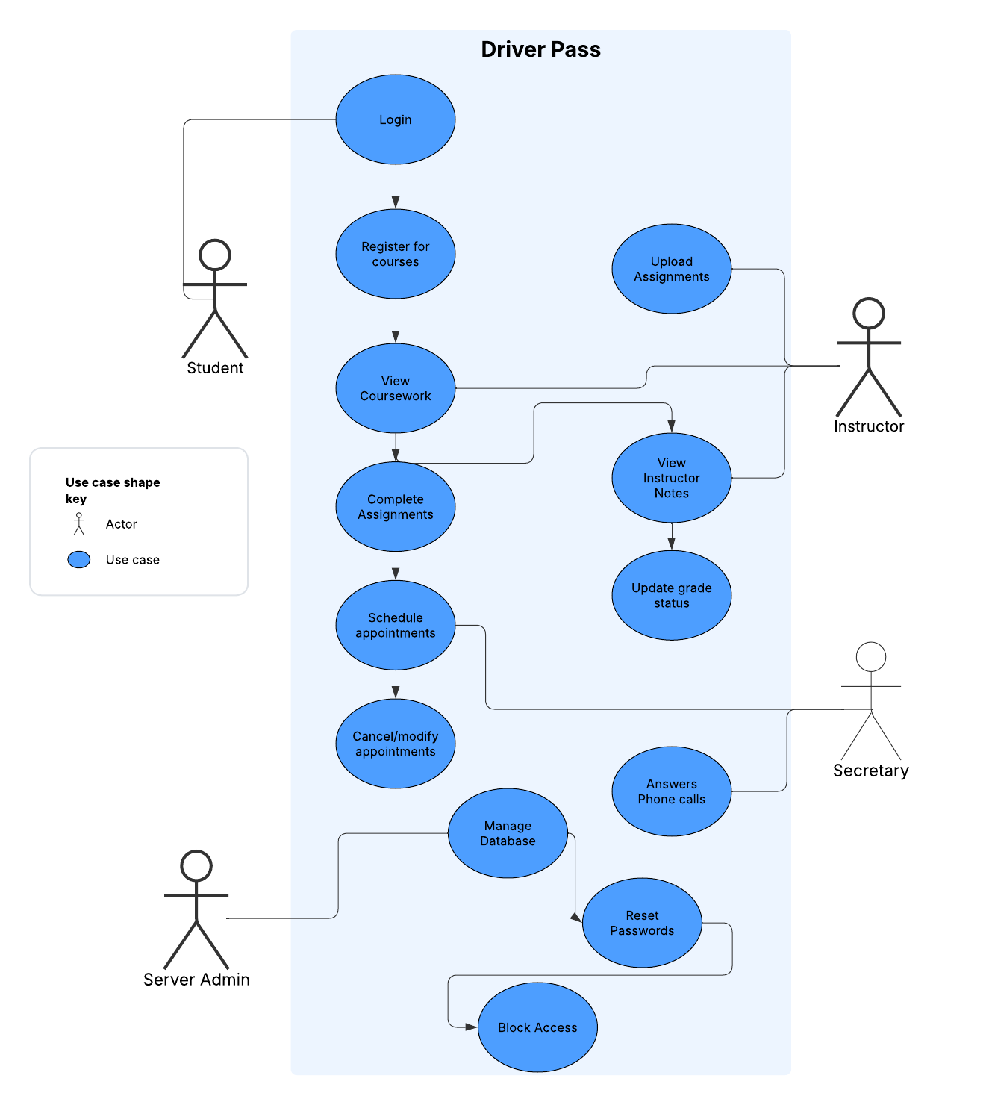

### UML Activity Diagrams

*Use case where a student needs to update their profile*

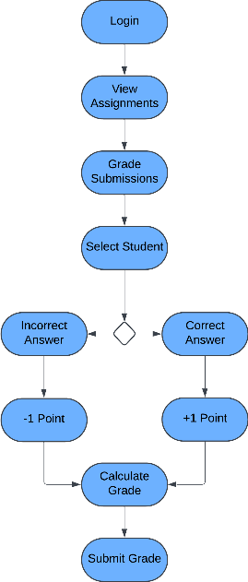

*Use case where instructor needs to grade student submissions*

### UML Sequence Diagram

### UML Class Diagram

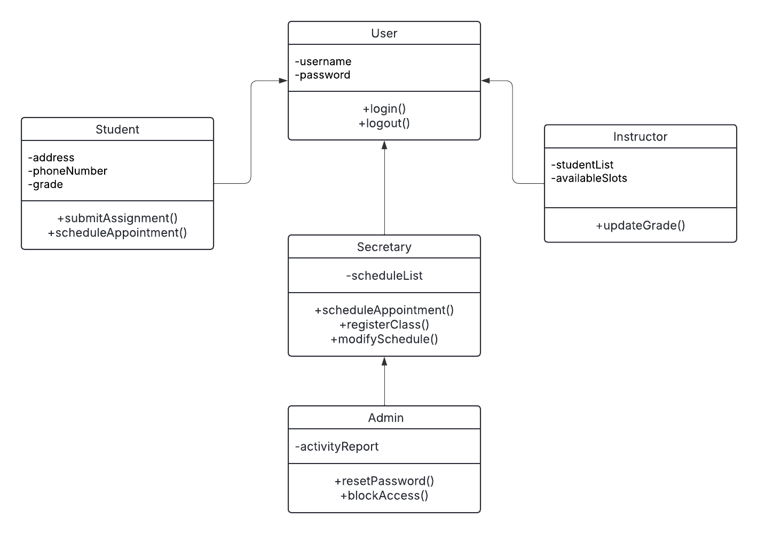

## Technical Requirements

-Desktop computer/laptop with peripherals or mobile smartphone required

-Desktop operating system must be Windows 11, MacOS 15 Sequoia

-Mobile operating system Android 15 or iOS 18

-Capable browsers such as Chrome, Firefox, Safari or Opera

-Internet access (WiFi or ethernet)